



**CODE PROMOTION IN JENKINS**

**&**

**EMAIL NOTIFICATION IN JENKINS**

**CONTENTS**

1. Promoted Build ..................................................................................................................3
2. How to make interrelate between two jobs ......................................................................3
   1. Upstream job ............................................................................................................3
   2. Downstream job .......................................................................................................3
3. Fingerprint..........................................................................................................................4
   1. How does Fingerprint work ......................................................................................5
   2. How to create Fingerprint ........................................................................................6
4. How to promote code in Jenkins .......................................................................................6
5. Email Notification ..............................................................................................................6
   1. Gmail settings ..........................................................................................................7
   2. How to configure Email Notification .......................................................................7

**Promoted Build:**

This plugin allows you to distinguish good builds from bad builds by introducing the notion of 'promotion’. Put simply, a promoted build is a successful build that passed additional criteria (such as more comprehensive tests that are set up as downstream jobs.) The typical situation in which you use promotion is where you have multiple 'test' jobs hooked up as downstream jobs of a 'build' job. You'll then configure the build job so that the build gets promoted when all the test jobs passed successfully. This allows you to keep the build job run fast (so that developers get faster feedback when a build fails), and you can still distinguish builds that are good from builds that compiled but had runtime problems.

**How to make interrelate between two projects?**

We can interrelate two jobs by using **Upstream** and **Downstream** concept.

1. First download two maven project form GitHub. And store in your local machine.

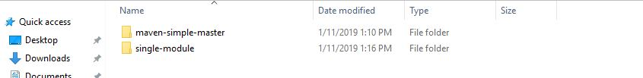

* So here I have two maven projects named **maven-sample-master** and **single-module**.

**Upstream job:**

An upstream job is a configured project that triggers a project as part of its execution.

* Upstream and Downstream job helps us to configure the sequence of execution for different operations and hence you can orchestrate the flow of execution. We can configure one or more project as downstream job in Jenkins.

**Downstream job:**

Downstream job is a configured project that is triggered as part of an execution of pipeline.

**Fingerprint:**

Jenkins fingerprinting is the way that Jenkins keeps tracking of a file across different build and jobs. Sometimes you have different job using the same produced file and it is hard to track if it’s using the proper version of this file. Fingerprinting is made for it.

**How does finger print works?**

The fingerprinting is a xml file stored in the $JENKINS_HOME/fingerprints directory on the Jenkins master.



And the xml file contains the following data:

* Timestamp
* Job name
* Build Number
* MD5 checksum
* Fingerprinted filename

**How to create fingerprint:**

First open your job, then go to the **Post-Build-Actions** -> then select **Record fingerprints of file to track usages.**

Then write your jar file name in **Files to fingerprint** section as below.

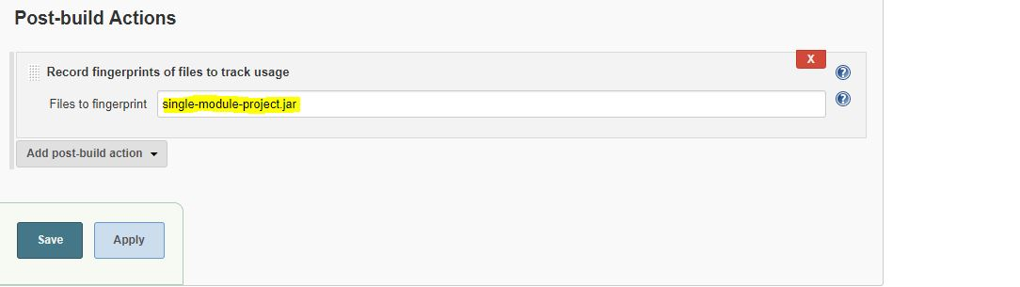

Then save and build the job, now you can see the following output.

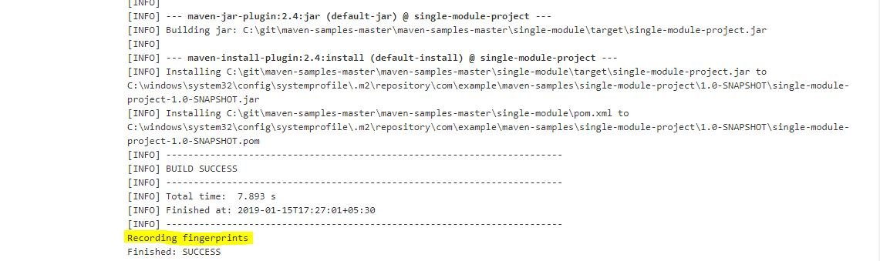

Now go to Jenkins folder and check the fingerprint.

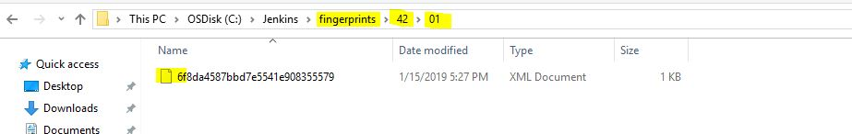

**How to promote code in Jenkins:**

We can promote code by using the concept of upstream and downstream.

* Here we have two maven projects.



* Suppose I am going to consider “**single-module”** as an upstream job (Parent) and **maven-project-master** is for downstream job(child).
* Now create the **fingerprin**t of both Upstream and downstream job.
* Then go to the pom.xml file of **Downstream job(child)** and add (Timestamp, job Name, Build Number, MD5 checksum, Fingerprinted file name) of **Upstream job(parent)** like below**.**

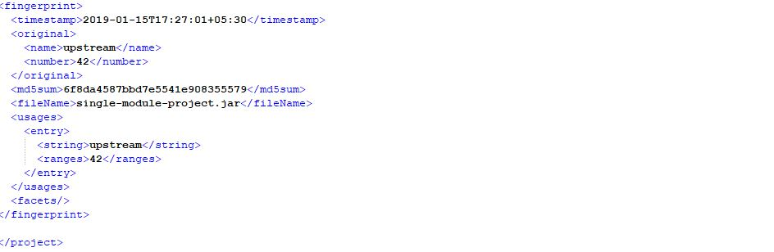

* Then save the pom.xml file.
* Then click ‘**promote build when’** option.

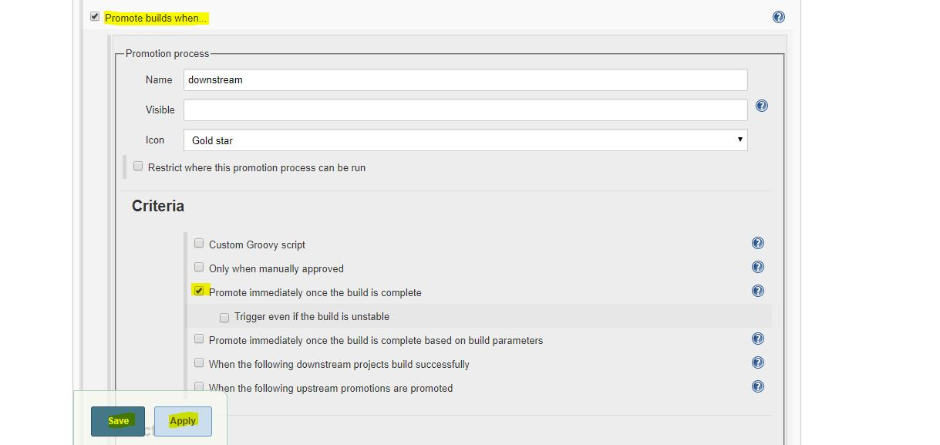

* Then go to Build Triggers and click **Build when another Project is promoted**.

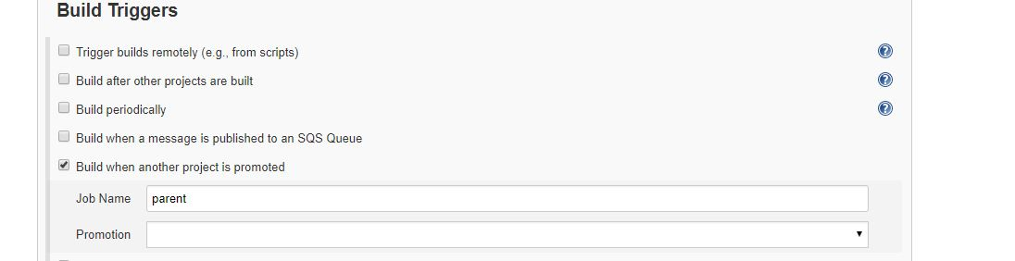

* Then save and click on ‘**Build Now’** option.
* Then go to the Downstream job and click on **promotion status** as per below diagram.

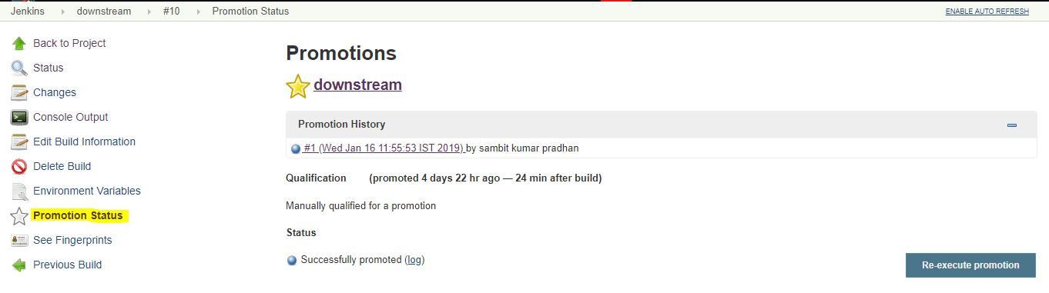

**How to configure email notification in Jenkins:**

**Overview**

If you will configure the Email Notification in Jenkins, then automatically it will send mail while you will build the job in Jenkins.

**Change Settings of Gmail Account:**

Before starting the work, first you Have to enable “**Less secure app access”** in your Gmail Account.

* To enable the option in Gmail, login to your account at Gmail.com, Then open another tab and then go “**Less security app access”** settings and select turn “**ON**”.

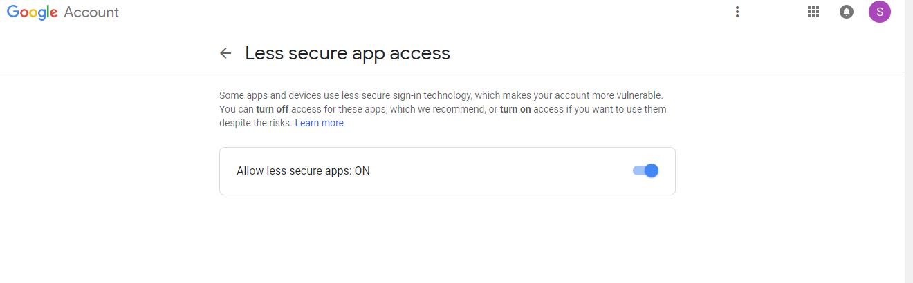

1. Then open Jenkins using the following <URL:http://localhost:8080>
2. Click the ‘**Manage Jenkins’** menu option displayed at the right side of the screen. You will be redirected to the ‘Manage Jenkins’ page, where you need to select the **‘Manage Plugin’** option.

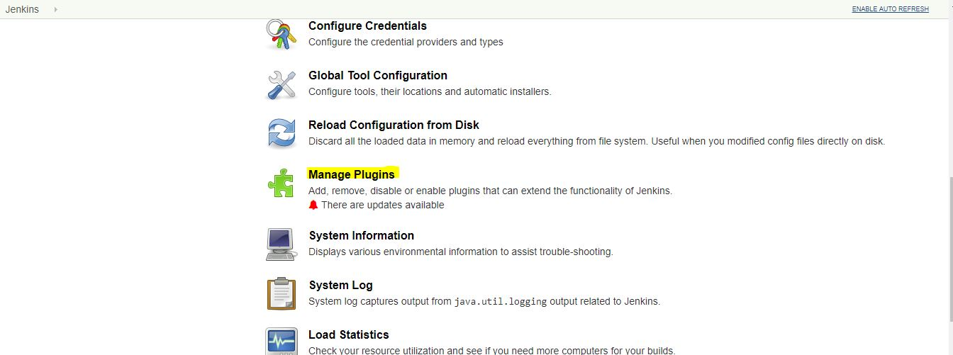

1. Click the ‘Available’ tab present at the top of the ‘Manage Plugin’ page.

pugindshu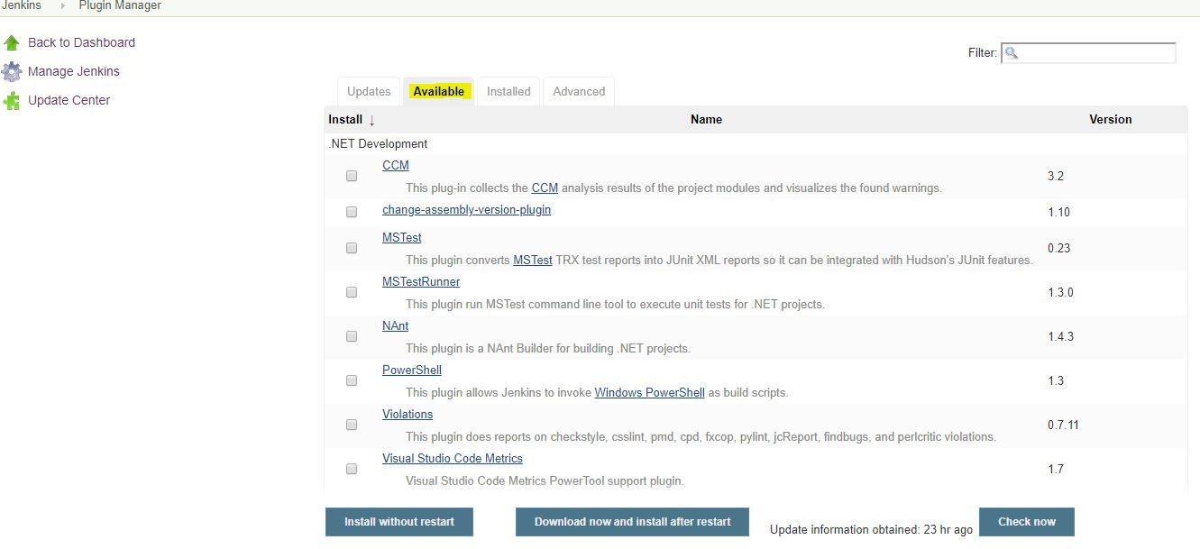

1. Start typing ‘Notification’ in the ‘Filter’ field displayed at the top-right side of the ‘Manage Plugin’ page. Click the checkbox next to the **‘Email-ext. plugin’** option. Click the ‘Install without restart’ button.
2. Go to the Jenkins home page and click the ‘**Manage Jenkins**’ menu option. Then, select the ‘**Configure System**’ option.

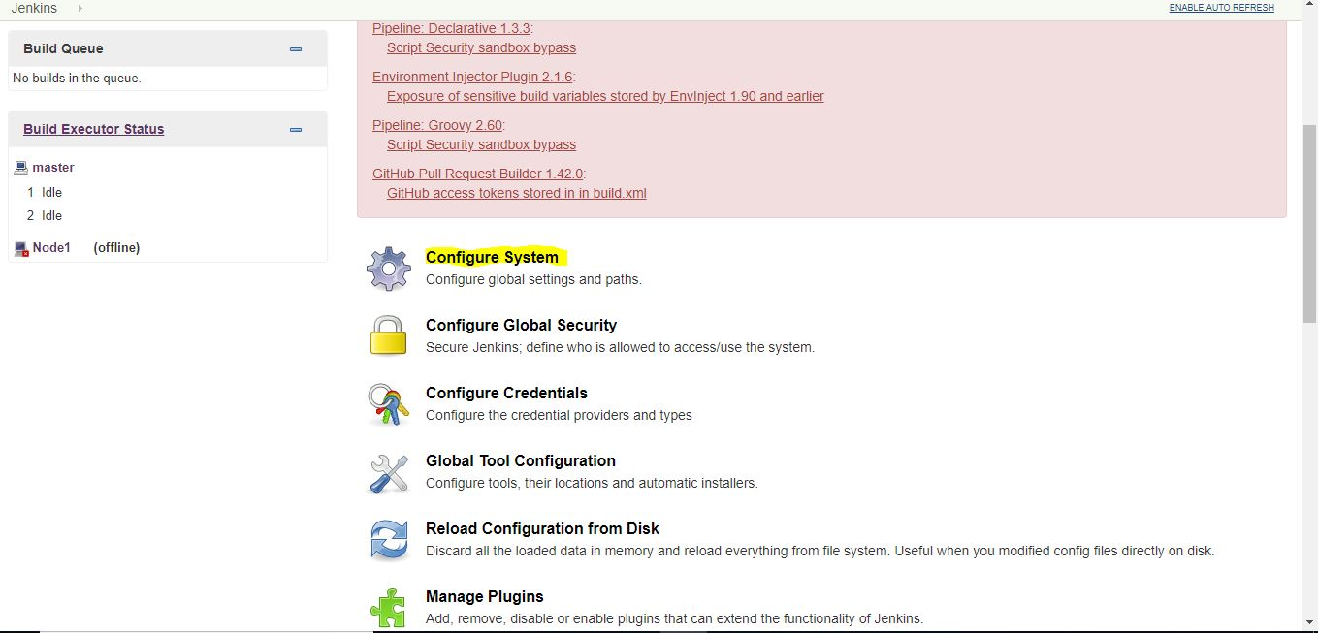

1. Enter the SMTP server name under ‘Email Notification’. Click the ‘Advanced’ button and then click the checkbox next to the ‘Use SMTP Authentication’ option. Now, set the following fields.
   1. **SMTP server name**: smtp.gmail.com
   2. **User name**: user_email_id@gmail.com
   3. **Password**: 123456
   4. **Use SSL:** Checked
   5. **SMTP Port**: 456
2. Check the email notification functionality by clicking the checkbox next to the ‘Test configuration by sending Test e-mail recipient’ option. Enter a valid email id and click the ‘Test configuration’ button to check whether the email id is valid or not.

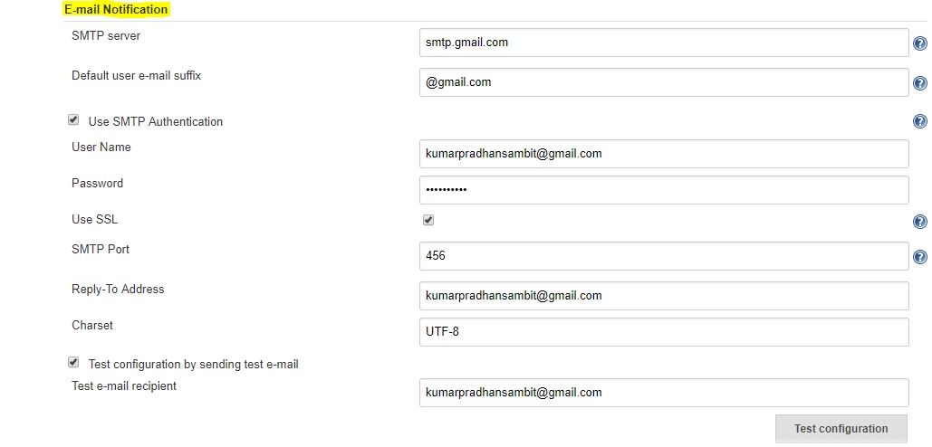

1. Go to the home page and click on a created job, like child. Then, click the ‘Configure’ option.

Then go to ‘**post build action’** drop-down. Then click the ‘Add post-build action’ drop-down and select the ‘Email Notification’ value.

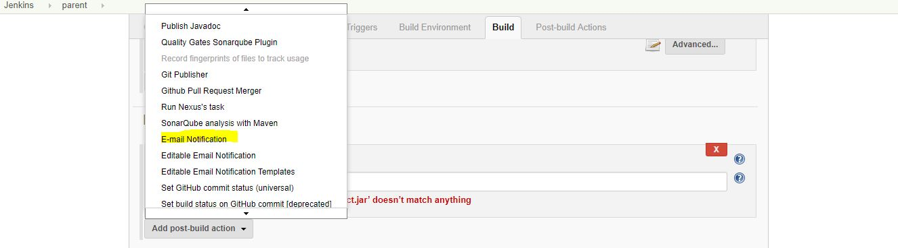

* Then enter your Mail id in the box and save it.

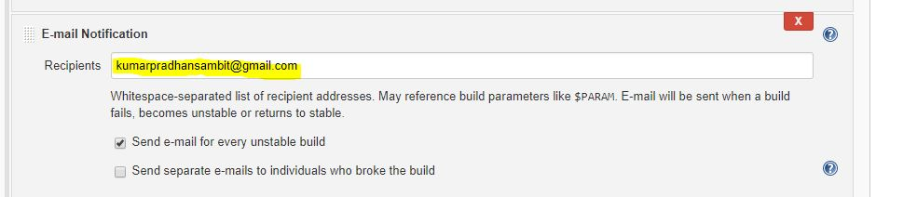

* Then click the **Add post build action**’ drop down and select ‘Editable Email Notification’ value.
* Then fill the **Editable Email Notification** fields as below.
* Type your mail id in **Project Recipient List** box.

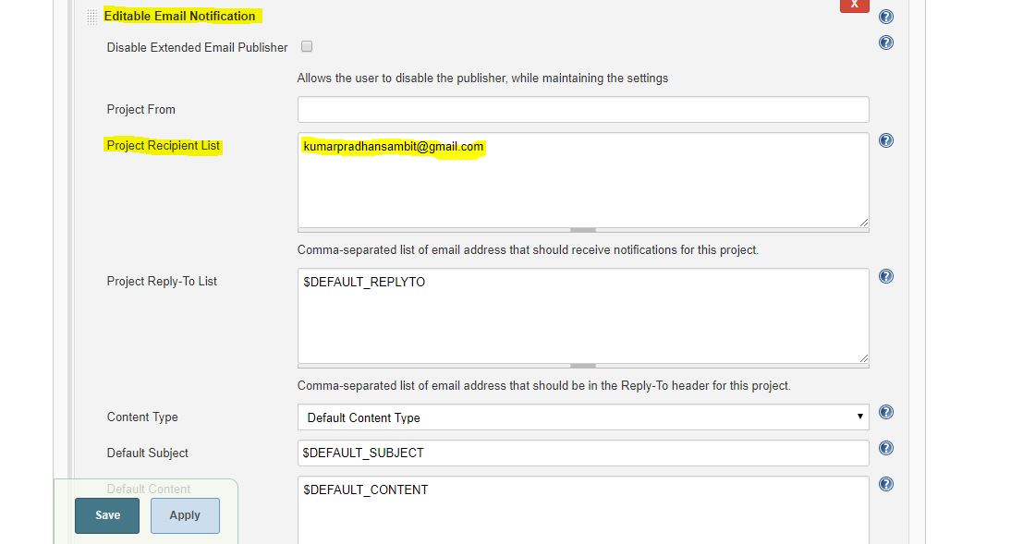

* Then click **Advance setting** of Editable Email Notification box.
* Click the ‘Add Triger’ drop down and select the **‘Always’** option.

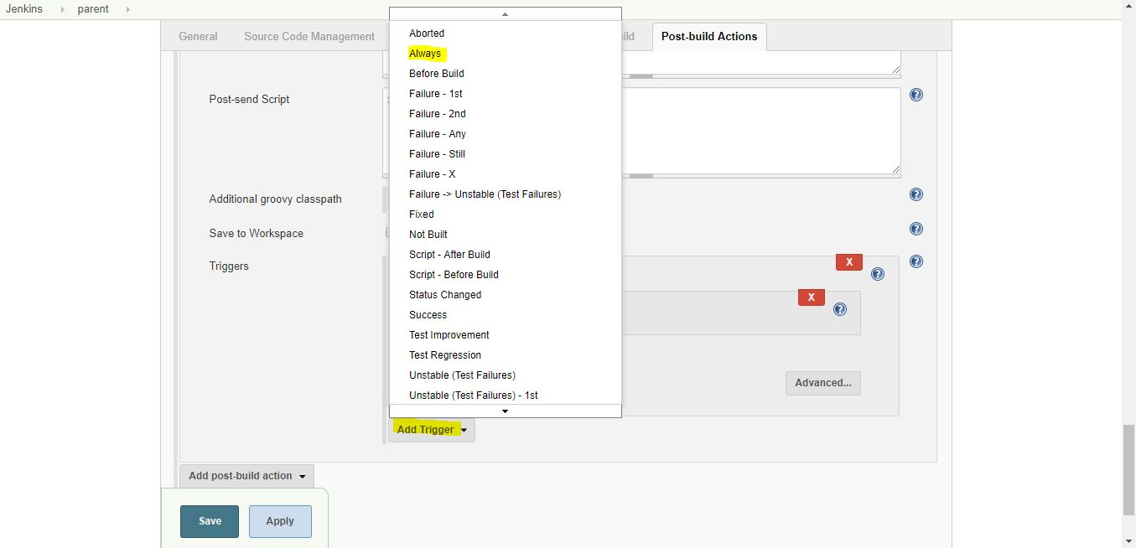

* Click the save option.
* Then click the ‘**Build Now’** option, then check the Email id after the job execution.

**Build Status:**

